Apply filters to SQL queries

Project description
In this project I had been working with a mock security team on a security incident. Our team had various issues when discovering failed login attempts. I needed to run multiple SQL queries in order to investigate login attempts and employee information under specific conditions.

Retrieve after hours failed login attempts
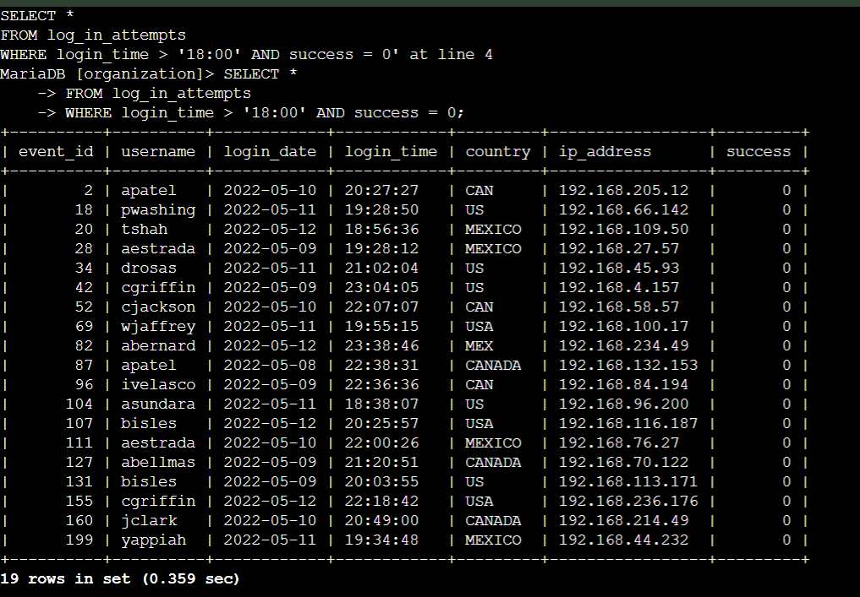
Our team investigated a recent potential security incident that occurred after business hours. Here I have demonstrated a query I used in order to investigate this incident. I used

SELECT *
FROM log_in_attempts
WHERE login_time > ‘18:00’ AND success = 0;

This query displayed any failed login attempts ( success =0; ) during times after business hours ( login_time > ‘18:00’ ).

Retrieve login attempts on specific dates
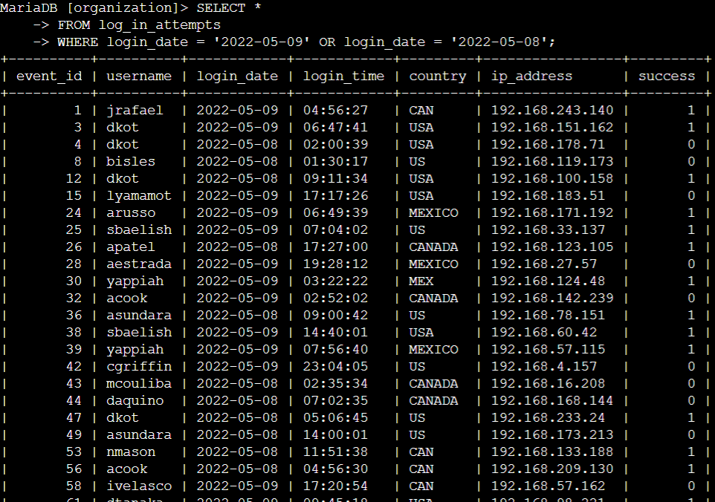
Another suspicious event had occurred on specific dates. They had occurred on ‘2022-05-09’ and the day before that. I ran a specific query that met these conditions. I used

SELECT *
FROM log_in_attempts
WHERE login_date = ‘2022-05-09’ OR login_date = ‘2022-05-08’;

This demonstrated the use of the OR filter to identify all login attempts that had occurred on 2022-05-09 or 2022-05-08.

Retrieve login attempts outside of Mexico
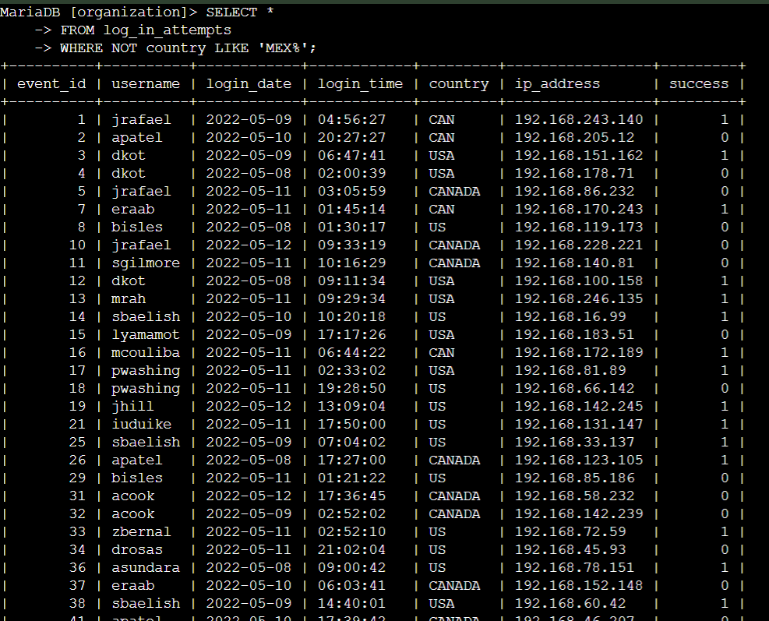
In this event our team had ruled out the possibility of Mexico being the origin of the suspicious activity. After this I ran a query in order to filter out Mexico from the result. This query was

SELECT *
FROM log_in_attempts
WHERE NOT country LIKE ‘MEX%’;

The NOT filter indicates a ruling out of Mexico and the LIKE filter searches all results containing ‘MEX%’. The % after MEX is used as a wildcard for any characters after MEX, this is because some results containing Mexico are entered as MEX or MEXICO.

Retrieve employees in Marketing
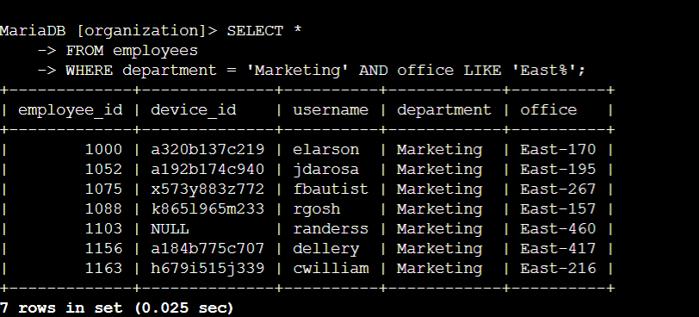
In this situation our team wanted to perform security updates on specific employee machines within the Marketing department. I had to use filters to create a query that identifies all employees in the marketing department for all offices in the East building. This query was

SELECT *
FROM employees
WHERE department = ‘Marketing’ AND office LIKE ‘East%’;

The AND filter combined the requirements of being in the marketing department as well as being in the East building. The LIKE filter combined with the % character set a condition of any office with East in the name as well as any character after East added to it to be selected.

Retrieve employees in Finance or Sales
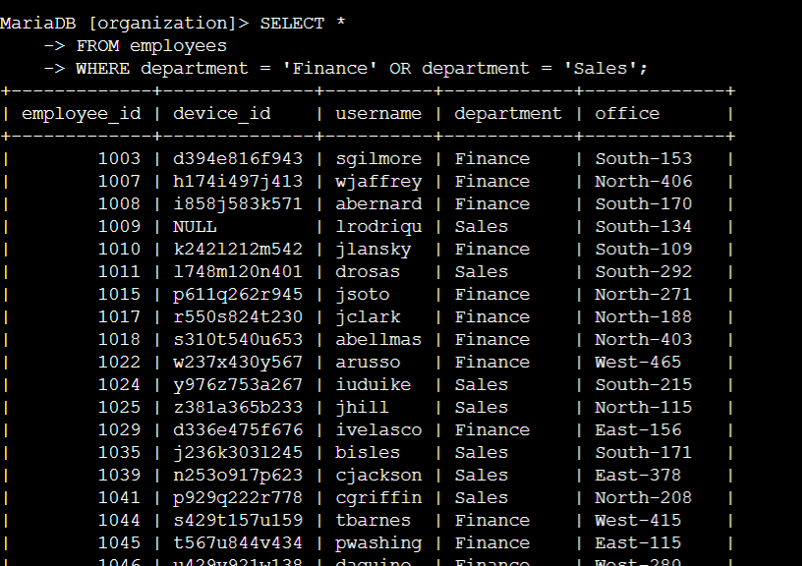
In this situation our team needed to perform new security updates on machines for employees in the Sales and Finance departments. I used filters in SQL to create a query that identified these employees. The Query I used for this was

SELECT *
FROM employees
WHERE department = ‘Finance’ OR department = ‘Sales’;

The OR filter set the requirements of only results with finance or sales in the name to be selected.

Retrieve all employees not in IT
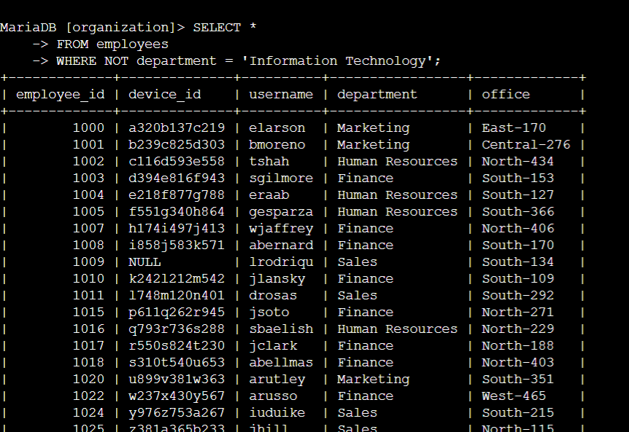
Our team needed one more update for all other departments except for the Information Technology department. In order to accomplish this I had to create a query in SQL that identified all employees not in the Information Technology department. This query was

SELECT *
FROM employees
WHERE NOT department = ‘Information Technology’;

The NOT filter set the requirements of every department that was not the Information Technology Department to be selected.

Summary
This project provided me with the necessary tools and knowledge to apply specific filters in SQL. I can now make specific queries to achieve specific results and apply this into a future cybersecurity role.

